
Experiment 4: Provision a VPS instance through a cloud provider or create a virtual machine on the local system using software such as VirtualBox or VMware. 2. Install a Linux distribution such as Ubuntu, CentOS, or Debian as the operating system. Set up the required network parameters, including IP address, subnet mask, gateway, and DNS.

AIM:
To create a Virtual Private Server (VPS) using VirtualBox, install Ubuntu Server, set up the network parameters (IP Address, Subnet Mask, Gateway, DNS), and enable remote access through SSH.

What is VPS?
A Virtual Private Server (VPS) is a software-based server created through virtualization technology. It functions independently with its own operating system, storage, memory, and network settings while sharing the physical hardware with other virtual machines. Virtualization helps utilize resources efficiently and provides the basic foundation for cloud computing platforms.
Network configuration parameters include:

IP Address
A unique address allocated to a device within a network.

Subnet Mask
Identifies the network portion and host portion of an IP address.

Gateway
Allows communication with networks beyond the local network.

DNS (Domain Name System)
Translates domain names into their corresponding IP addresses.

SSH (Secure Shell)
A secure protocol used to remotely administer Linux systems.

PROCEDURE:
- Open the Ubuntu terminal and test the internet connection by executing the ping google.com command.
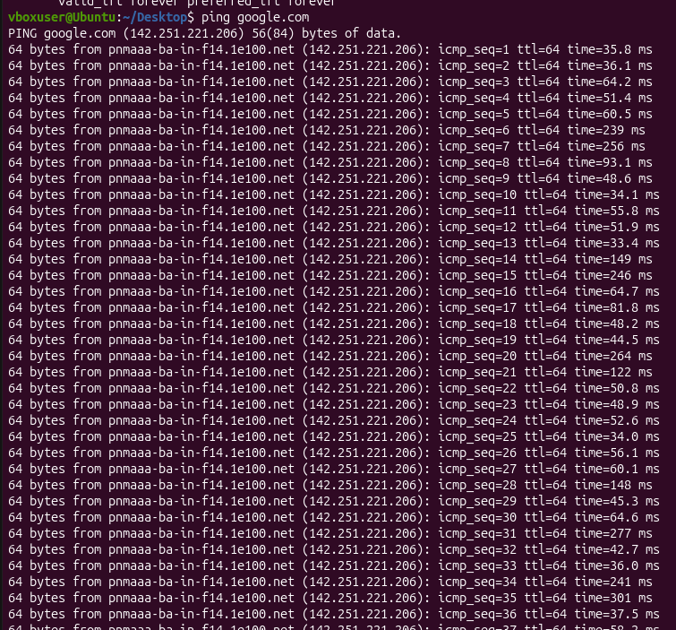
- View the network routing details by using the ip route command.
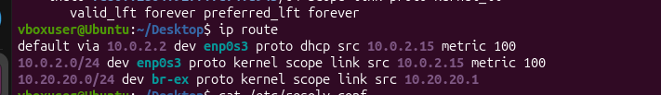
- Check the system's DNS (Domain Name System) configuration using the cat /etc/resolv.conf command.

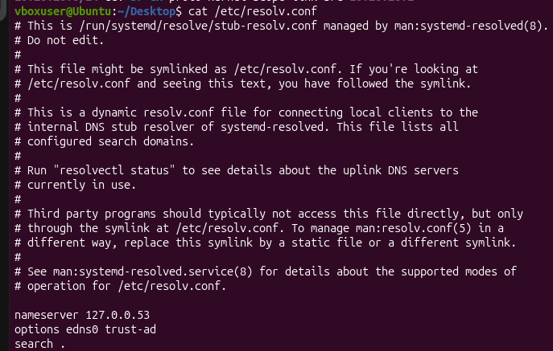
- If necessary, refresh the Ubuntu package list using: sudo apt update
- Install the OpenSSH Server package by executing: sudo apt install openssh-server -y
- Enable and start the SSH service with the following commands:
- sudo systemctl enable ssh
sudo systemctl start ssh
- Verify that the SSH service is running successfully using: sudo systemctl status
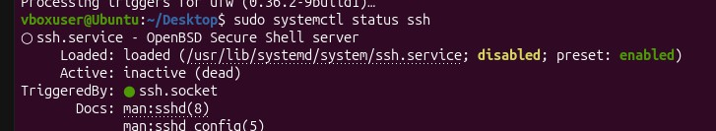
- Obtain the IP address of the Ubuntu system using: Hostname -I
- Connect to the Ubuntu system through SSH using: ssh <username>@<IP_address>

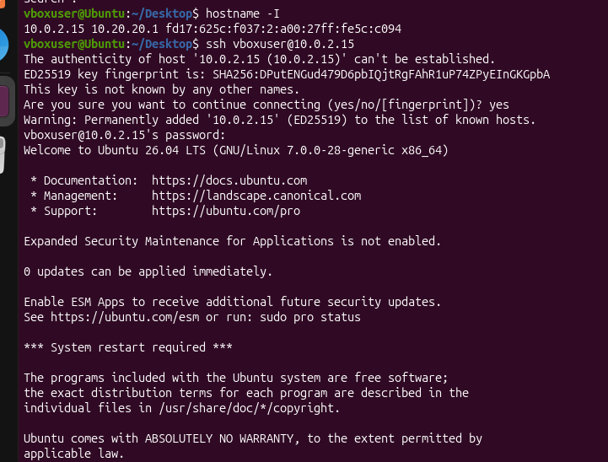
- Confirm the successful SSH login by checking for the "Welcome to Ubuntu" message shown in the terminal.

Conclusion:
The Ubuntu system was successfully configured and its network connectivity was verified. The OpenSSH Server was installed and enabled, and the SSH service was confirmed to be active. The system's IP address was obtained, and an SSH login was successfully performed. Therefore, secure remote access to the Ubuntu system was successfully established.

